Diversity in child and YA lit
Table of Contents…………………………………………………………………………………………………………..........1
Musings & Ponderings, Publishing 101……………………………………………………………………………………….….2
Publishing Statistics People of Color & First/Native Nations and by People of Color First/Native Nations……………………………………………………………………………………………………….………………………………….2
History………………………………………………………………………………………………………….…………….……………...….2
What do the Numbers Mean?.............................................................................................................2
Making a Difference……………………………………………………………………………………………………………………....3
Children's Books by and About People of Color and First/Native Nations Received by the CCBC* 2002 –
……………………………………………………………………………………………………………………………………………………….4
Children's Books by and About People of Color and First/Native Nations Received by the CCBC*--US Publishers Only 2015 –………………………………………………………………………………………………………………….. 5
Children's Books by and About People of Color and First/Native Nations Received by the CCBC* 1994-2001…………………………………………………………………………………………………………………………………………..…..5
Children's Books by Black Authors and Illustrators Published in the United States 1985-1993……….6
CCBC 2017 Statistics on Multicultural Literature…………………………………………………………………………….6
An early-November analysis of the 698 picture books we'd received so far in 2017 from U.S. publishers revealed………………………………………………………………………………………………………………………………………….6
Diversity Gap in Children's Book Publishing 2018……………………………………………………………………………7
Diversity Gap in Children's Literature 24 Yrs. 1994-2017…………………………………………………………………8
The number is steadily increasing………………………………………………………………………………………………… ..9
So, What Happens Now?................................................................................................................... ..9
Embracing Diveristy in Children's Literature………………………………………………………………………………….10
…On Diversity in Library Collections………………………………………………………………………………………………10
Diversty in children's Books 2015………………………………………………………………………………………………….11
Diverse Children and Young Adult Literature………………………………………………… 11
African, African American……………………………………………………………………………….. 11
American Indian………………………………………………………………………………………………… 12
Book Awards………………………………………………………………………………………………………. 12
Disabilities…………………………………………………………………………………………………………. 12
Islam…………………………………………………………………………………………………………………… 12
LGBTQIA…………………………………………………………………………………………………………….. 12
Latinx ………………………………………………………………………………………………………………………………………...13
Multicultural……………………………………………………………………………………………………….13
Country Awards…………………………………………………………………………………………………………………………….13
Social Justice……………………………………………………………………………………………………… 14
Translation Award…………………………………………………………………………………………………………………………14
Musings & Ponderings, Publishing 101

If we were to shrink the population of the world to 100 people while still maintaining the ratios of today, this is what our village would look like:
- 61 Asians
- 12 Europeans
- 5 US Americans and Canadians
- 8 Latin Americans
- 14 Africans

- 51 would be male,
- 49 would be female
- 82 would be non-white;
- 18 white

- 67 would be non-Christian;
- 33 would be Christian

- 80 would live in substandard housing
- 67 would be unable to read
- 24 would not have any electricity
- 76 that do have electricity—most would only use it for light at night
- 7 people would have access to the Internet

- 1 would have a college education
- 1 would have HIV
- 2 would be near birth;
- 1 near death

Musings & Ponderings, Publishing 101
More Diverse than You Thought?
July 20, 2010 leeandlowbooks Leave a comment
http://blog.leeandlow.com/2010/07/20/more-diverse-than-you-thought/#more-2203

Cooperative Children's Book Center (CCBC), School of Education, University of Wisconsin-Madison

Publishing Statistics on CCBC about People of Color and First/Native Nations and by People of Color and First/Native Nations
History
In 1985 the Cooperative Children's Book Center began to document the numbers of books we received each year that were written and/or illustrated by African Americans...Of the approximately 2,500 trade books that were published in 1985, only 18 were created by African Americans, and thus eligible for the Coretta Scott King Award.
What Do the Numbers Mean?
What we know from being immersed in children's and young adult literature each and every day is that white people are not notably, or even noticeably, lacking in books for children and teens…
More important, what the low numbers for multicultural literature mean is that publishing for children and teens has a long way to go before reflecting the rich diversity of perspectives and experiences within and across race and culture.
Making a Difference
Across the years, we've seen evidence of the importance of small, independently owned publishers as contributors to a significant body of authentic multicultural literature for children in the United States and Canada. The commitment of individual editors at both large and small publishing houses also has made an impact.
We have also noted the importance of children's book awards in calling attention to outstanding work created by and about people of color and First/Native Nations people. We encourage you to visit our multicultural literature page for links to multicultural literature awards and other resources.
Sales matter to publishing. The books themselves matter to children and teens, who deserve to see the rich diversity of their lives and the world in which they live reflected in the books around them each and every day.
People of Color and First/Native Nations Authors and Illustrators Documented by the Cooperative Children's Book Center, School of Education, University of Wisconsin-Madison http://ccbc.education.wisc.edu/books/pcstats.asp

Statistical Charts follow

Children's Books by and About People of Color and
First/Native Nations Received by the CCBC*
2002 -
Last Updated: February 22, 2018

Year | Number of Books  Received  at CCBC  (approx.) | African /  African Americans |  | American Indians / First Nations |  | Asian Pacifics/  Asian Pacific Americans |  | Latinos
 |  | By | About | By | About | By | About | By | About
2017 | 3,700 | 122 | 340 | 38 | 72 | 274 | 310 | 116 | 216
2016 | 3,400 | 94 | 287 | 23 | 55 | 217 | 240 | 104 | 169
2015 | 3,400 | 108 | 270 | 19 | 42 | 176 | 113 | 60 | 85
2014 | 3,500 | 85 | 181 | 20 | 38 | 129 | 112 | 59 | 66
2013 | 3,200 | 69 | 94 | 18 | 34 | 90 | 69 | 49 | 58
2012 | 3,600 | 69 | 119 | 6 | 22 | 83 | 76 | 58 | 54
2011 | 3,400 | 79 | 123 | 12 | 28 | 76 | 91 | 52 | 58
2010 | 3,400 | 102 | 156 | 9 | 22 | 60 | 64 | 55 | 66
2009 | 3,000 | 83 | 157 | 12 | 33 | 67 | 80 | 60 | 61
2008 | 3,000 | 83 | 172 | 9 | 40 | 77 | 98 | 48 | 79
2007 | 3,000 | 77 | 150 | 6 | 44 | 56 | 68 | 42 | 59
2006 | 3,000 | 87 | 153 | 14 | 41 | 72 | 74 | 42 | 63
2005 | 2,800 | 75 | 149 | 4 | 34 | 60 | 64 | 50 | 76
2004 | 2,800 | 99 | 143 | 7 | 33 | 61 | 65 | 37 | 61
2003 | 3,200 | 79 | 171 | 11 | 95 | 43 | 78 | 41 | 63
2002 | 3,150 | 69 | 166 | 6 | 64 | 46 | 91 | 48 | 94

Children's Books by and About People of Color and
First/Native Nations Received by the CCBC*--US Publishers Only
2015 -
Last Updated: February 22, 2018

Year | Number of Books  Received  at CCBC from US Pubs | African /  African Americans |  | American Indians / First Nations |  | Asian Pacifics/  Asian Pacific Americans |  | Latinos
 |  | By | About | By | About | By | About | By | About
2017 | 3,500 | 116 | 319 | 18 | 44 | 256 | 300 | 108 | 205
2016 | 3,200 | 92 | 267 | 8 | 35 | 195 | 225 | 95 | 157
2015 | 3,200 | 106 | 244 | 9 | 28 | 156 | 107 | 56 | 79

Children's Books by and About People of Color and
First/Native Nations Received by the CCBC*
1994-2001

Year | Estimated Total Number of  Books Published | African /  African-Americans |  | Asian Pacific /  Asian Pacific Americans | American Indian | Latinos
 |  | By | About | By and About | By and About | By and About
2001 | 5,000-5,500 | 99 | 201 | 96 | 60 | 77
2000 | 5,000-5,500 | 96 | 147 | 57 | 40 | 54
1999 | 5,000 | 82 | 151 | 61 | 41 | 64
1998 | 5,000 | 96 | 188 | 52 | 55 | 73
1997 | 4,500-5000 | 88 | 216 | 66 | 64 | 88
1996 | 4,500 | 92 | 172 | 49 | 50 | 103
1995 | 4,500 | 100 | 167 | 91 | 83 | 70
1994 | 4,500 | 82 | 166 | 65 | 70 | 90

Children's Books by Black Authors and Illustrators
Published in the United States
1985-1993

Year | Estimated Number of  Books Published | Total Number of Books  by Black Authors and Illustrator
1993 | 4,500 | 74
1992 | 4,500 | 94
1991 | 4,000 | 70
1990 | 5,000 | 51
1989 | 4,000 | 48
1988 | 3,000 | 39
1987 | 3,000 | 30
1986 | 3,000 | 18
1985 | 2,500 | 18
People of Color and First/Native Nations Authors and Illustrators Documented by the Cooperative Children's Book Center, School of Education, University of Wisconsin-Madison, http://ccbc.education.wisc.edu/books/pcstats.asp

CCBC 2017 Statistics on Multicultural Literature Of the approximately 3,700 books we received at the CCBC in 2017, most from U.S. publishers, here's the breakdown:
- 340 had significant African or African American content/characters.
- 100 of these were by Black authors and/or illustrators. (29.41% #OwnVoices)
- 72 had significant American Indian/First Nations content/characters.
- 38 of these were by American Indian/First Nations authors and/or illustrators. (52.78% #OwnVoices)
- 310 had significant Asian/Pacific or Asian/Pacific American content/characters.
- 122 of these were by authors and/or illustrators of Asian/Pacific heritage. (39.35% #OwnVoices)
- 216 had significant Latinx content/characters.
- 73 of these were by Latinx authors and/or illustrators. (33.8% #OwnVoices)

An early-November analysis of the 698 picture books we'd received so far in 2017 from U.S. publishers revealed:
- A character in a picture book was 4 times more likely to be a dinosaur than an American Indian child.
- A character in a picture book was 2 times more likely to be a rabbit than an Asian/Pacific or Asian/Pacific American child.
- A female character in a picture book was highly likely to be wearing pink and/or a bow, even if she is a hippopotamus, an ostrich, or a dinosaur.
- A child with a disability appeared in only 21 picture books, and only 2 of those were main characters. Most others appeared in background illustrations.
- We will continue to evaluate the data for the 2017 publishing year in the coming weeks and will post additional information on this blog. At the same time, we are expanding our diversity analysis in 2018 to include a deep dive into all of the books we receive: picture books, fiction, and nonfiction.
http://ccblogc.blogspot.com/2018/02/ccbc-2017-multicultural-statistics.html
This post is adapted from” Publishing in 2017: A Few Observations," an essay that will appear in the forthcoming CCBC Choices 2018 publication.

The Diversity Gap in Children’s Book Publishing, 2018

In February, the Cooperative Children’s Book Center (CCBC) released its statistics on the number of children’s books by and about people of color published in 2017. In 2016, we witnessed a substantial increase in the number of diverse books being published. Diversity remains an ever-evolving topic in publishing when it comes to books as well as the diversity among the authors and illustrators creating them.

So what has changed since last year?

Infographic follows
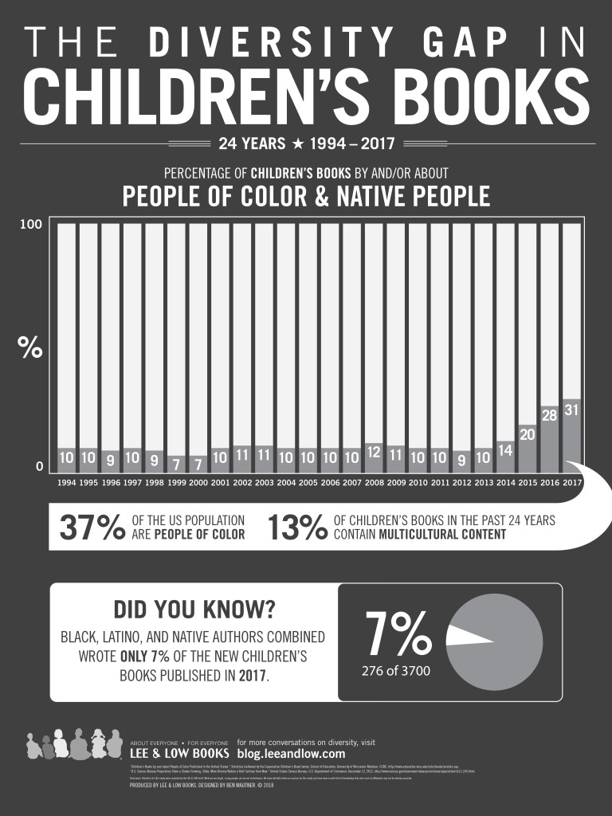

The number is steadily increasing…
Starting in 2014, the number of diverse books being published increased substantially. And in 2016, the number jumped to 28%. This year shows that number is steadily increasing, hitting 31% – now the highest year on record since 1994. Like 2016, there were major award wins for authors of color in 2017, including a Newbery Medal for Erin Entrada Kelly, a Newbery Honor for Jason Reynolds, Renée Watson, Derrick Barnes and Gordon C. James, and a Morris Award and Printz Honor for Angie Thomas.

But still…

Even as the number of diverse books increases substantially, the number of books written by people of color still has not kept pace. Not much has changed since last year when Black, Latinx, and Native authors combined wrote just 6% of new children’s books published. This year the number is only 7%.

Like last year and many of the years before, the majority of books (diverse or not) are still written by white authors.

There still seems to be a particular resistance to allowing African American creators to tell their own stories. It could also be the lack of opportunities and/or access given to African American authors as KT Horning noted last year. According to detailed CCBC statistics, only 29% of books about African/African American people were by Black authors/illustrators. Also, only 34% of books about Latinx folks were written/illustrated by Latinx people whereas last year the percentage was 61%.

Other #ownvoices books by other cultural groups aren’t much better; 39% of books about Asian Pacific/Asian Pacific Americans were created by Asian Pacific creators; 53% of books with Native content/characters were written/illustrated by Native creators.

So, What Happens Now?
It’s great that the number of diverse books continues to increase, but we’re still left with similar questions from last year:
- Why are we still giving preference to white authors telling diverse stories rather than authors of color/Native authors?
- Why are Black, Brown, and Native authors and illustrators still so underrepresented?
- What efforts (if any) are publishers making to diversify the creators they work with?

We’re looking forward to the day creators of color will be able to tell their own stories and be given the same opportunities to write stories with animal characters or talking inanimate objects that white authors are given. As the CCBC begins to track books with LGBTQIA+ content, we hope to see more LGBTQ+ characters of color and more intersectionality in regards to characters of color with disabilities. But change will only happen when publishing recognizes that equity is crucial, that the world is rapidly changing, and that creators of color deserve the chance to have their voices heard too.
Diversity, Diversity, Race, and Representation, The Diversity Gap
The Diversity Gap in Children’s Book Publishing, 2018
http://blog.leeandlow.com/2018/05/10/the-diversity-gap-in-childrens-book-publishing-2018/
May 10, 2018 Jalissa 14 Comments

Embracing Diversity in YA Lit

Librarians can make sure to include diverse books in their collection development budget, even if their communities are not diverse. “Look for awesome books no matter what the characters’ backgrounds may be. Even if your community isn’t diverse, the world is. Buy your books accordingly. Seek out resources to help you booktalk those titles. The resources are out there; become aware of them and use and share them with your colleagues.”
Embracing Diversity in YA Lit
By Shelley Diaz on September 12, 2013
https://www.slj.com/2013/09/teens-ya/embracing-diversity-in-ya-lit/

…On Diversity in Library Collections
American children today are a part of a culturally diverse country and…world, yet research by the Cooperative Children’s Book Center (CCBC) and other groups suggests that children’s books published as recently as 2015 still do not reflect this growing diversity…
For libraries, as reported by Naidoo (2014), regular exposure to diverse collections helps children build positive self-images, validates lived experiences, and fosters cross-cultural connections locally and globally….
Children respond to stories in which characters that look like them or share similar characteristics or behaviors, and illustrations play a significant part in this process. In her article on children’s book illustrations, Roethler (1998) discusses how each child goes through “identity formation” and visual literacy’s role in this development. According to Roethler, children are repeatedly exposed to images through books, and these images become part of the child’s “schemata” that partially inform how they view themselves (p. 97 Roethler argues that illustrators who are white can unwittingly pass along their prejudices in their “interpretation.” Black illustrators, however, are more likely to understand their own culture, just as Asian, Latino, and Native-American illustrators are…
Librarians have a voice and they choose what is purchased for their libraries and what… [books are] displayed, read…or promoted. Librarians must ensure that all children “see” themselves in some part of the collection…
…Promoting diverse collections can stimulate young patrons’ imaginations and creativity by helping them look beyond the range of their own experiences…The positive impact on young patrons will be life-long and far-reaching.
Week 11: On Diversity in Library Collections
Posted on April 21, 2017April 24, 2017
https://amethystdreamsblog.wordpress.com/2017/04/21/week-11-on-diversity-in-library-collections/
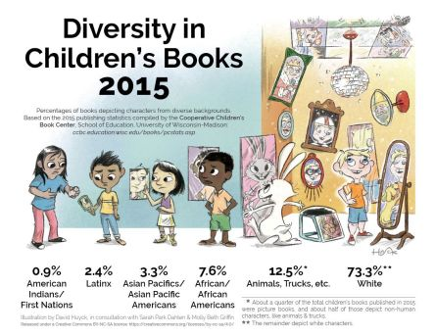
Huyck, David, Sarah Park Dahlen, Molly Beth Griffin. (2016 September 14). Diversity in Children’s Books 2015 infographic. sarahpark.com blog. Retrieved from https://readingspark.wordpress.com/2016/09/14/picture-this-reflecting-diversity-in-childrens-book-publishing/

Diverse Children and Young Adult Literature

African, African American
Africa Access Review
Children's Africana Book Awards—Africa
Coretta Scott King Book Awards—African American
The Brown Bookshelf
The Dark Fantastic
NAACP Image Awards for Outstanding Children's Literature—African American

American Indian
American Indians in Children's Literature
A Critical Bibliography of North American Indian for K-12
SLJ's Resources and Kid Lit About American Indians

Book Awards
The American Indian Youth Literature Awards—American Indians and Alaska Natives
Americas Book Awards—Latinx, Latin America, Caribbean or Latinos in the US
Arab American Book Award—American Muslims
Asian/Pacific American Award for Literature—Asian
Carter G. Woodson Book Award—Ethnicity and race relations
Children's Africana Book Awards—Africa
Coretta Scott King Book Awards—African American
The Jane Addams Children's Book Awards—Social Justice
Lambda Literary Award —LGBTQIA
Mildred L. Batchelder Award—ALA, the most outstanding children’s book originally published in a language other than English in a country other than the United States, and subsequently translated into English for publication in the United States.
Middle East Book Awards—Islam
NAACP Image Awards for Outstanding Children's Literature—African American
New Voices Award—unpublished authors of color for a picture book manuscript
Pura Belpre Award--Latinx
The Scholastic Asian Book Award—Asian
South Asia Book Award—Asian
Schneider Family Book Award—Disabilities
Stonewall Book Awards—LGBTQIA
Sydney Taylor Book Award—Jewish
Tomas Rivera Book Award—Mexican American experience
Walter Dean Myers Award—Diversity

Disabilities
Disability in Kidlit
Schneider Family Book Award

Islam
SLJ's Islam in the Classroom
Middle East Book Awards—Islam
Arab American Book Award—American Muslims

LGBTQIA
ALA's Rainbow List
Great Gay Teen Books
I'm Queer I'm Here, What the Hell Do I Read?
SLJ's LGBTQ Book List
Stonewall Book Awards—LGBTQIA

Latinx
Americas Book Awards—Latinx, Latin America, Caribbean or Latinos in the US
Colorin Colorado
Latin@s in Kid Lit
Mamiverse Books
Pura Belpre Award--Latinx
SLJ's Gateway Latino Books
SLJ: Libro por Libro
Tomas Rivera Book Award—Mexican American experience
Vamos a Leer

Multicultural
Carter G. Woodson Book Award—Ethnicity and race relations
CCBC Multicultural Literature List
Children's Peace and Anti-Bias Library of Cabrillo Community College
Crazy QuiltEdi
Crystal Brunelle's recommendations
Cynthia Leitich Smith's Blog
Diversity in YA
Elizabeth Bluemle's A World Full of Color
The Guardian: List of 50 Best Culturally Diverse Children's Books
I'm Your Neighbor
KQED Mindshift Book List
Mildred L. Batchelder Award—ALA, the most outstanding children’s book originally published in a language other than English in a country other than the United States, and subsequently translated into English for publication in the United States.
Notable Books for a Global Society
The Pirate Tree
Reading in Color
Rich in Color
Skipping Stones Honor Awards:--Skipping Stones Magazine, multicultural and nature books.
SLJ: Betsy Bird's Casual Diversity Book List
SLJ's Culturally Diverse Book List
SLJ Expanded Cultural Diversity List
SLJ's Tales of Child Refugees and Safe Havens
Smithsonian BookDragon
Walter Dean Myers Award—Diversity

Country Awards:
Aurealis Award—Australian Premier awards for speculative fiction
Australian Prime Minister Literary Awards –Australian Government Department of Communication & arts
Ethel Turner Prize—Australia, State Library of New South Wales best fiction, non-fiction or poetry written for young people of secondary school level
Eve Pownall Award—Australia, Children’s Book Council of Australia
Patricia Wrightson Prize—Australia, State Library of New South Wales
TD Canadian Award— Canadian Children’s Book Centre & TD Bank Group Best literary work for children by a Canadian author
Norma Fleck Award—Canadian Children’s Book Centre best Non-Fiction
Geoffrey Bilson Award—Canadian Children’s Book Centre best Historical Fiction
Governor General's Award—Canadian Children’s Book Centre best YA Nonfiction and YA Illustrated Books
Marilyn Baillie Award—Canadian, Children’s Book Centre best Picture Book
Amy Mathers Award—Canadian Children’s Book Centre Teen Book Award
John Spray Award—Canadian Children’s Book Centre Best YA Mystery Book
Ruth and Sylvia Schwartz Award—Canadian Ontario Best Picture book and YA/Middle Reader book
Esther Glen Award—New Zealand Junior Fiction
Margaret Mahy Award—New Zealand Best Children’s Book of the Year
Elsie Locke Award—New Zealand for Non-Fiction
Russell Clark Award—New Zealand Picture book and Illustration
Copyright Licensing NZ Award—New Zealand Young Adult Fiction
Costa Book Award--one of the most prestigious and popular literary prizes in the UK and Ireland.
Royal Society Young People's Book Prize—Favorite science book in the UK

Social Justice
Christopher Award, Books for Young People
The Jane Addams Children's Book Awards—Social Justice
Social Justice Books’ “See What We See”
The above taken from https://diversebooks.org/resources/where-to-find-diverse-books/ (The diversebooks.org data was augmented by me for this workshop)
We Need Diverse Books™ is a grassroots organization of children’s book lovers that advocates We We Need Diverse Books™ is a 501(c)(3) non-profit and a grassroots organization of children’s book lovers that advocates essential changes in the publishing industry. Our aim is to help produce and promote literature that reflects and honors the lives of all young people.
Above taken from https://diversebooks.org/about-wndb/

Translation Award

Mildred L. Batchelder Award—ALA, the most outstanding children’s book originally published in a language other than English in a country other than the United States, and subsequently translated into English for publication in the United States.
Outstanding International Book List—United States Board on Books for Young People USBBY has selected an honor list of international books for young people.

